**inSight 2017**

**Department : Computer Science department**

**Problem Title : Automated schedule tracker**

**Problem Code : PS05**

**Problem Description :**

The students meet the faculties every now and then and there is a high probability that they have to wait for the faculty since he/she is not free at that particular time. In order to avoid this application should be built in such a way that all the faculties or the people in the office (admin/main office) update their schedule. The calendar will be designed in such a way that it will reflect the timings when faculties are available and hence avoid the waiting time. Depending on the faculties free slot, the students may request a meeting. The meeting should be scheduled only if the faculty confirms .This application will be useful any official (including the principal) in the department. This should keep both student and faculties informed about all the schedules that they need.

**Proposed solution:**

The idea here is to design a prototype of an Automated Schedule Tracker proposed by the given problem statement. We will design an android application which would consist of a two party login interface for *faculty* and *student* respectively. The faculty sign ups and enter his details which would be saved to the database. The faculty’s Activity would consist of a range-bar with thumbs on either side. The minimum of the range would be synced with the system time and the maximum would be synced with the time when the college ends (preferably between 5 to 7pm). Each time the faculty could save a range of free slot time by pressing a button and that slot would be added as a list view to his activity. He would also have an access to a requests activity that would have a record of meeting requests from students. Here, he could simply accept or reject the request of the student followed by sending a notification to the student.

The student’s activity would also have a login page followed by another activity i.e. a faculty list view, which would consists of all the faculties registered with the app. Clicking on a list element would open another activity with the details about the free time slots of the corresponding faculty in a list view. When the student clicks on the time slot display he would receive an alert dialog on his screen asking the user whether he is sure about requesting a meeting with that particular faculty probably followed by an option for reason of meeting. Pressing ‘yes’ would just send the request as a notification to the faculty. The faculty could now simply cancel or accept the request.

Additional feature that we propose to add to the faculty interface: We are currently working on Google’s text recognition API, through which the faculty can just click an image of their timetable and the text describing the time slots reserved in indulging classes would be also saved day wise in order to give them an idea about their reserved slots.

The prototype would certainly fulfil all the aspects of an Automated Schedule Tracker and would definitely rule out the specified problem where the students have to wait for the faculty since he/she is not free at that particular time.

**Technology Stack :**

* **Android Studio**
* **Firebase**
  + **Database**
  + **Notifications and messages**
  + **Storage Management**
* **Google Text Recognition API**

**Use Case:**

Faculty logs in

Student logs in

Faculty Activity

(Adds free Time Slots)

Student Activity

(Checks for wanted faculty)

Database

Notification

Requests Activity

Confirms or cancels requests

Faculty free time slots list view

Requests for meeting on the specified time slot by pressing a button

Notification

This is basically an android application which contains the initial login activity which is common to both the **students** and **teachers :-**

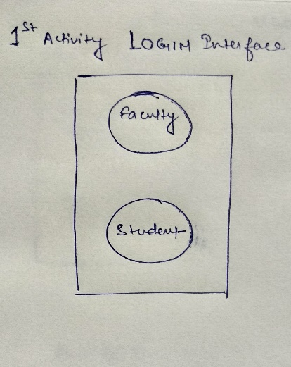

then after clicking on lets say **Faculty** it will take you to the Faculty Login Activity or screen :-

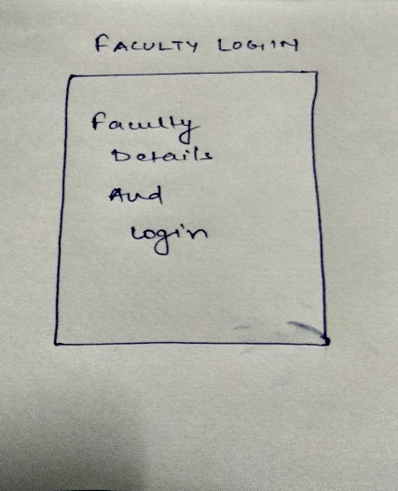

After filling the details (if 1st time user then need to fill the basic details if not then just do login), then you will be taken to Faculty Activity where the faculty can add there free slots by setting the seekbars starting time and ending time and clicking the button “Add to free slot”, it will add the free slot in the list view using array adapter in list view :-

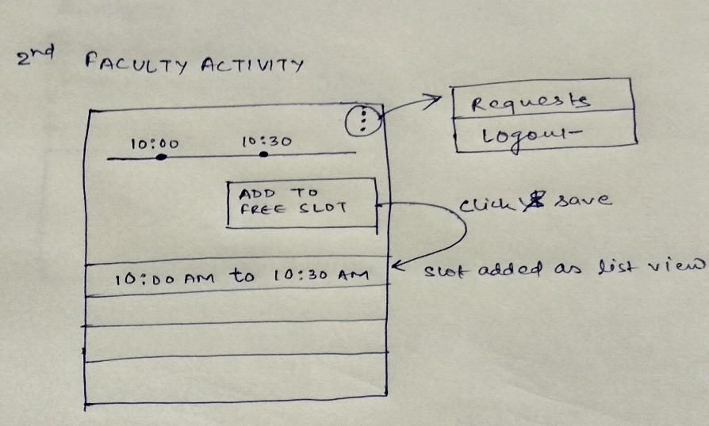

Now by clicking on the menu in the android action bar will show a dropdown menu having Requests and Logout as its fields, by clicking the requests button it will show a Request Activity where all the request for the meeting will be displayed with two buttons i.e confirm or cancel. Faculty can either confirm their request or can cancel there request based on the reason for the meeting.

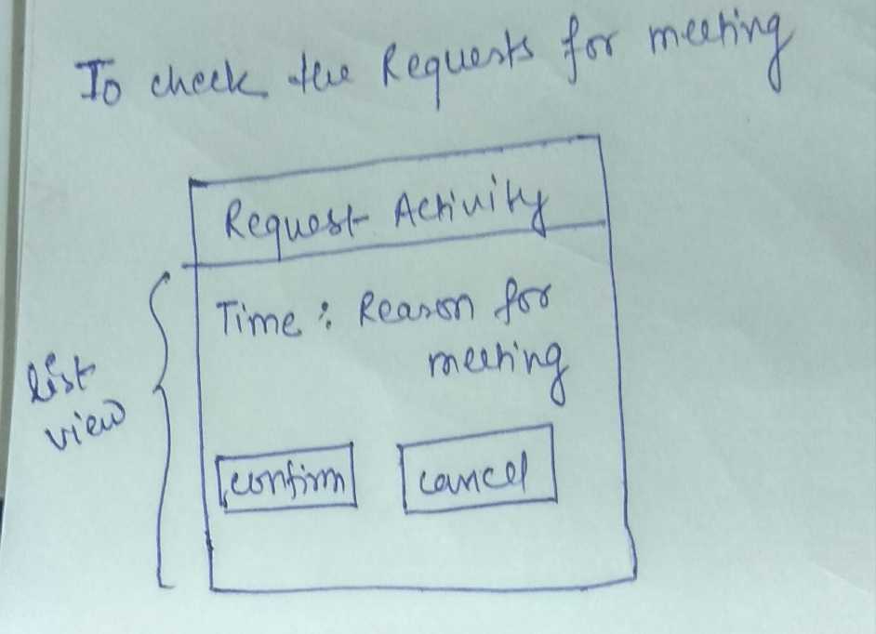

Either if the faculty confirms or cancels the student who has requested will get a notification for the same.

Now coming to the Student perspective :-

1st is the student login where if the student is the 1st time user then he has to fill the general details and if not then he can just do login.

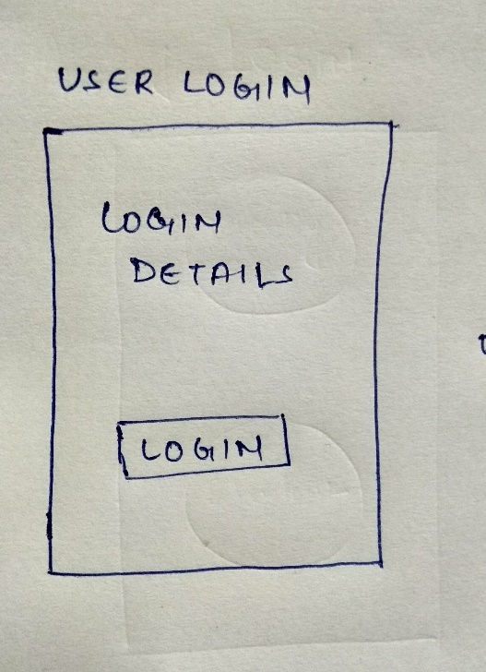

After login he will be taken to another activity Student Activity where he can see the list of faculties where he can just select or click on any of the faculty name and he will be taken to another activity meeting.

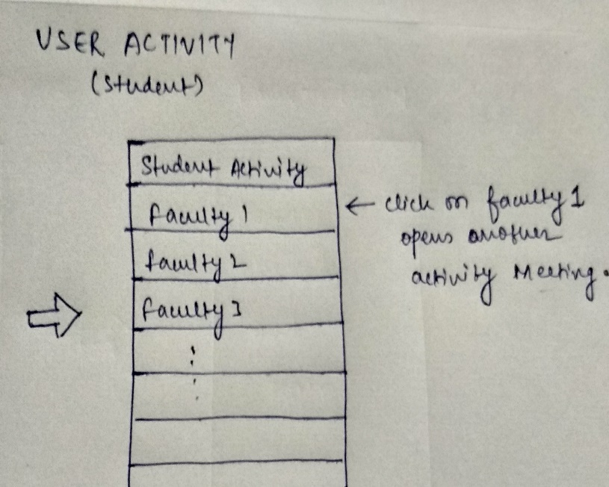

Here in meeting activity of the selected faculty the time slots in which the faculty is free will be shown the student just need to click on the time slot and a dialog box will appear asking for confirmation “Are you sure to request a meeting ? ” with two buttons either yes or no pressing a yes will notify the faculty about a student requesting for meeting then if the faculty confirms the request then the student will be notified about the confirmation or cancelation by the faculty according to which student can contact the desired faculty for meeting.

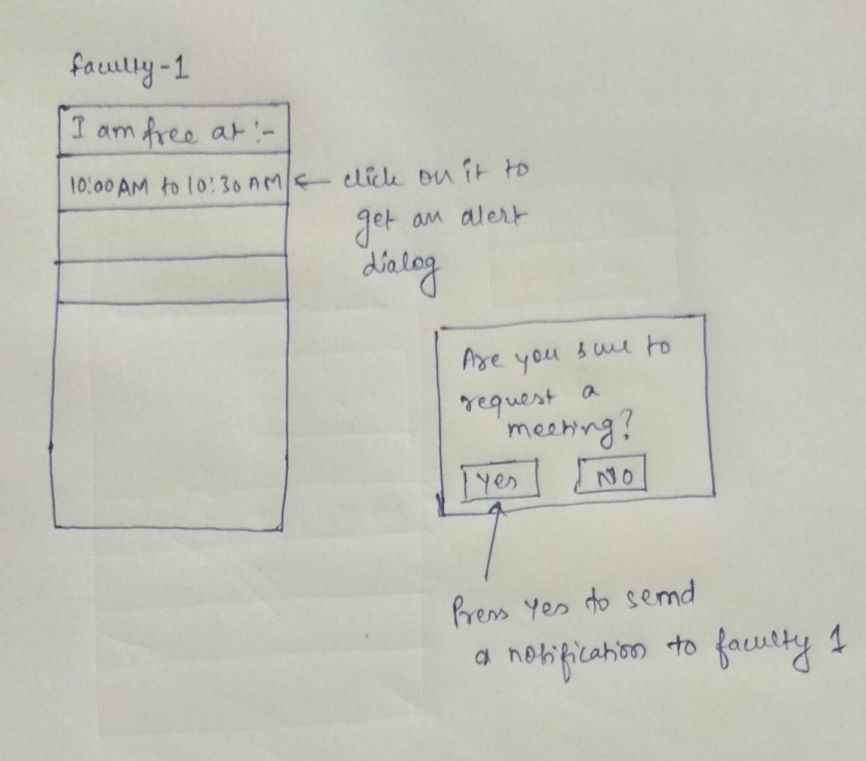

**Team Members details:**

|  |  |  |  |  |
| --- | --- | --- | --- | --- |
| **Role** | **Name** | **USN** | **Email id** | **Phone no.** |
| Team Leader | Mayank Agrawal | 1SI15CS141 | agrawalmayank0271@gmail.com | 7022265462 |
| Team Member 1 | Ashank Bharati | 1SI15CS140 | [bharatiashank1996@gmail.com](mailto:bharatiashank1996@gmail.com) | 7204589985 |